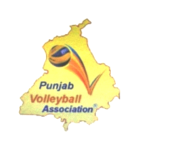 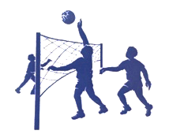 

LUDHIANA VOLLEYBALL ASSOCIATION

Affiliated to Punjab Volleyball Association

President

**D.P Sharma**

M- 9360900003

9915400039

General Secretary

**S. Jagroop Singh**

M- 9646100043

7778000007

[secretarybrarpva@gmail.com](mailto:secretarybrarpva@gmail.com)

[dcptrafficldh@gmail.com](mailto:dcptrafficldh@gmail.com)